Logarithm
Studies show poems help students succeed
But is that really true?
Can rhymes on a sheet
Truly help me succeed
Can words on a paper
In a ramble
Help me solve a logarithm

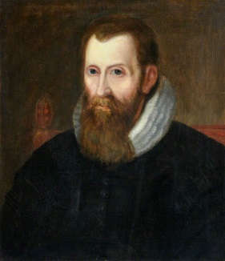
Who is John Napier
And why
Why in the world
Did he create logarithms
But without knowing logarithms
I will fail Algebra II
And have to learn this all over again

Let me take my time
$\log_{4}{X}$ + $\log_{4}{8}$ = 3
And quickly realize
I must pass this lifelong lesson
And first I must recognize
Is there a log on one side
And a number on the other?
$\log_{4}{8X}$ = 3
If so, I must make the log side as one single logarithm

Secondly
But surely not the most important
I must write it as an exponential function
Okay, so maybe it is the most important
Without the exponential function
$4^{3}$ = 8X
There would be no X
There would be a log still
And if there were no X
There’d be nothing to solve for

The third step
The final step
64 = 8X
X = 8
The end of the horrific journey
After all the calculations
Of adding logarithms together
And exponential functions
I can now finally
Solve for X

Now I know how to solve logarithms

Baily Broussard

